# SSY 130 - Applied Signal Processing

## Hand in Problem 2: FIR Differentiator filter design

Date: 04-12-23

Name: Jahanvi Bhadrashetty Dinesh

Student ID: 20000524

Secret Key: Wynaut

**Question 1:**

FIRPM command implements the Parks–McClellan Optimal FIR filter design algorithm to design and implement efficient FIR filters. The code below performs approximate differentiation for low frequencies up to 0.05 Hz and it blocks all frequencies above 0.1Hz. We use the firpm in the “differentiator” mode so that there is a 90 degrees constant phase shift whenever the filter is used.

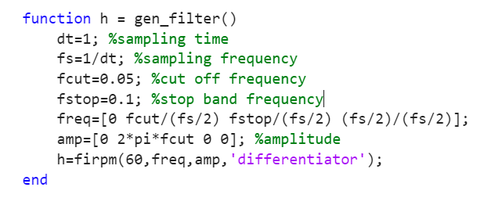

**Question 2:**

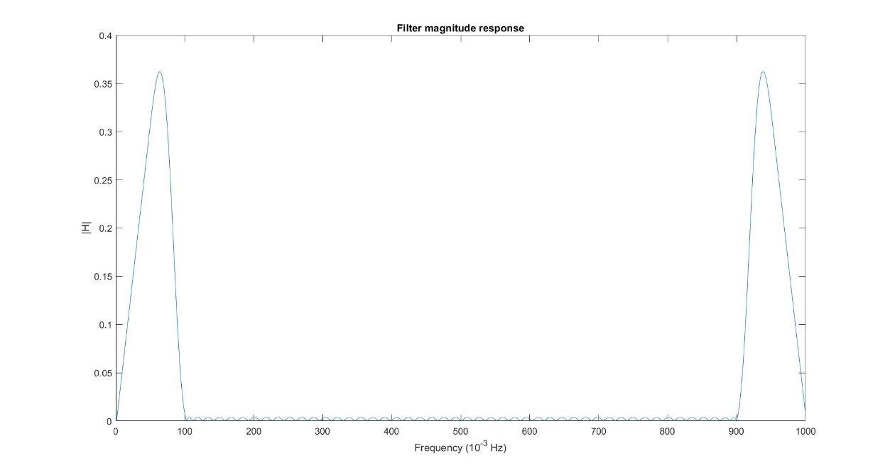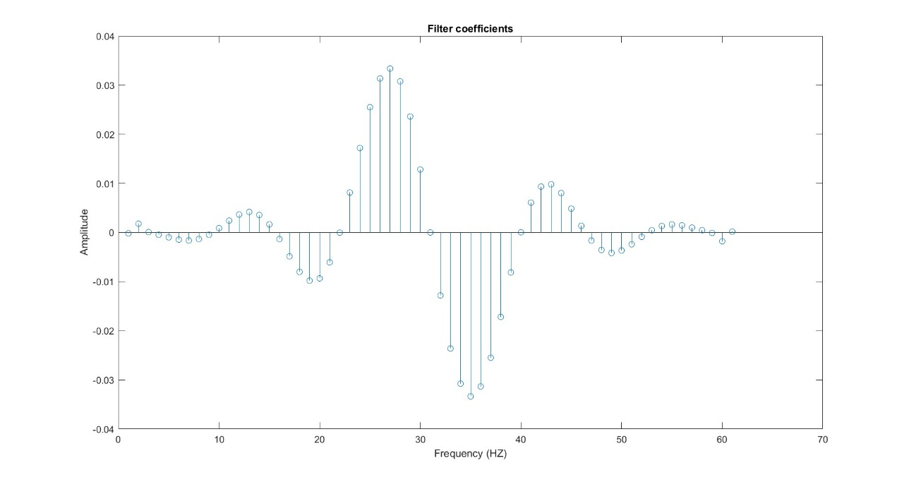

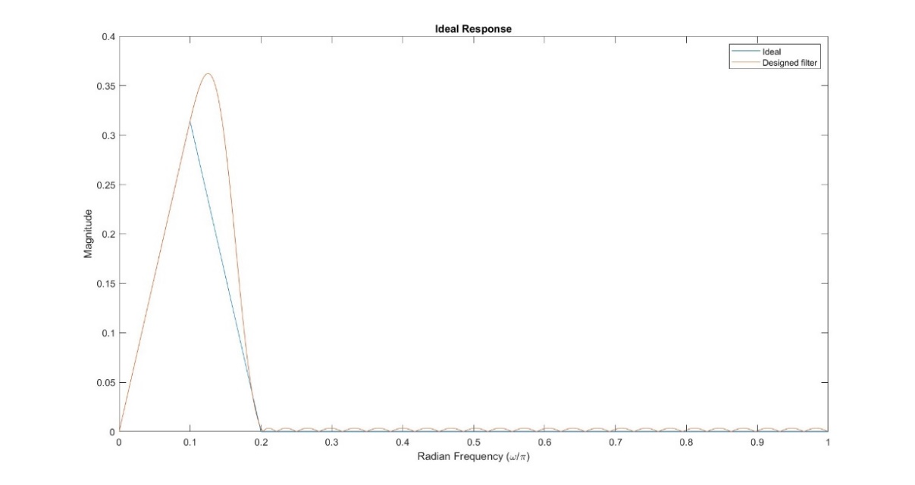

**Question 3:**

A signal passed through firpm filter will have a delay -

- where Ts = Sampling time.

We are given that the length of the data (M) is 61, therefore we get a delay of 30 seconds. So the output signal from the filter is shifted in time by 30 seconds when compared to the input signal entering the filter. We are designing an odd filter with M = 61(odd). So the ideal impulse response is truncated into M samples within the system. Hence there is a delay in the designed filter.

**Question 4:**

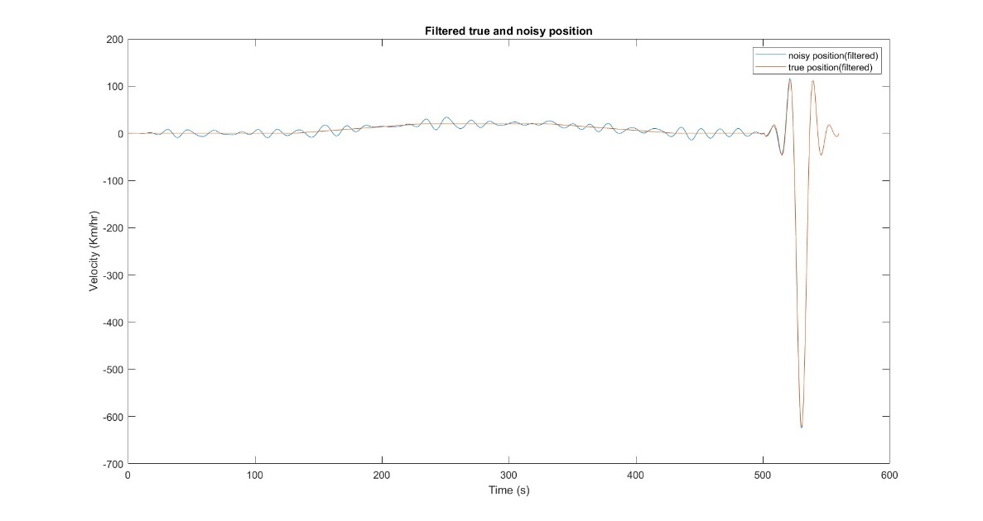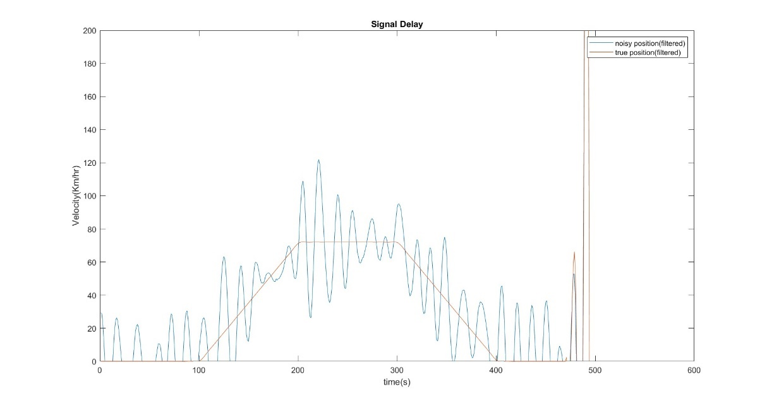

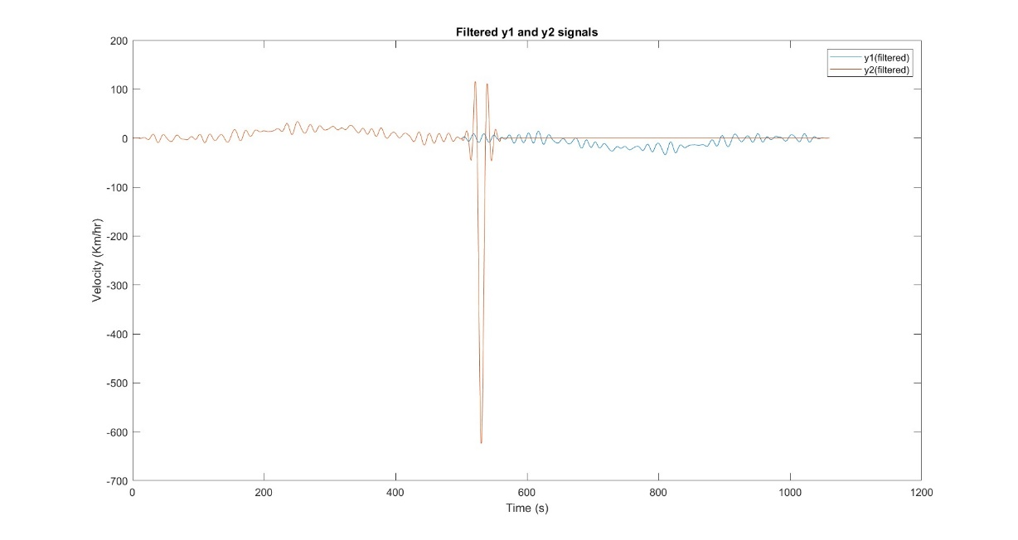

At the end of the filter output, there is large oscillation because of a mismatch in the sizes of signals and filter while performing convolution. The signal has a size M and the filter is of size N. So after convolution, the resulting output signal will have a length of M+N-1. Here the filter will try to zero-pad(or make equal to 0) the last N-1 elements which in turn result in huge oscillations(i.e huge position displacement and consequently huge velocity)

It can be observed that the plot of *y2(filtered)* looks very similar to the plot of *noisy_position(filtered)*.

**Question 5:**

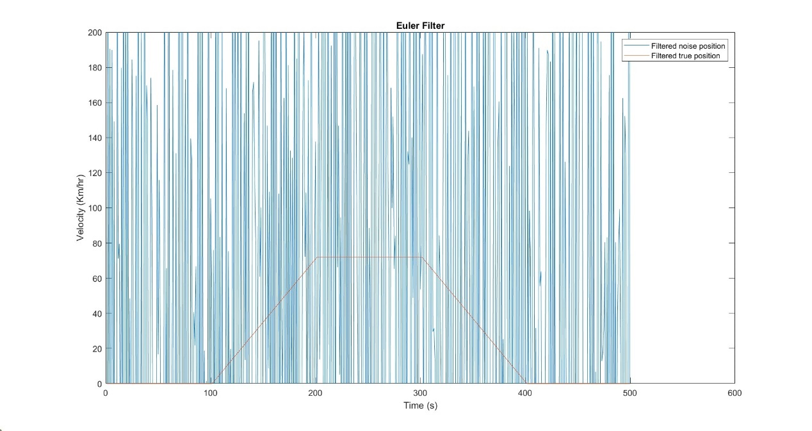

It is observed that when we apply Euler filter, the noise dominates the signal because the high frequency components will have amplified magnitudes. This is because taking derivative in time domain is the same as multiplying the signal with jω, in the frequency domain. In order to fix this, we should first filter the noise and then take the derivative.

**Question 6:**

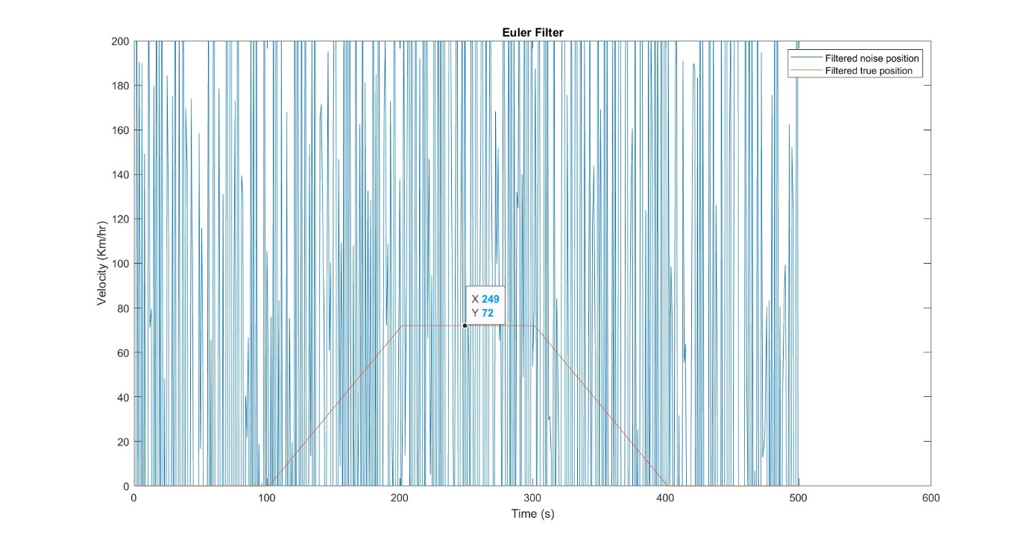

By processing data based on true and observed signal by Signal convolution with Euler’s filter and scaling of axis we observe the maximum speed of the vehicle -

From the figure, speed = 72 km/h